In order to impose the theme of employability skills into a game. It was decided that the game would become a board game that took inspiration from Monopoly: using a mixture of cards, dice and individual or group based players to progress the game.

The premise of the game was that there were jobs with different skill sets listed. The players’ objective was to collect as many of the scattered skills across the board, either for themselves or for their team. Ultimately, the player or team with the most collected skill would be declared the winner of that game.

Much like any game, rules were also placed down to control the difficulty of the game as well as the player’s actions:

* Skills were logged by the player through the use of skill cards. Once certain squares have been occupied by the player, they must either discard or pick up a skill card.
* Only one type of skill card can be obtained per game
* Cards that have been discarded can be retrieved if one lands on a square that allows for skills cards to be picked up.

To progress through the game, players were supposed to be given a pair of dice that moves them forward along the board. The objective of the game was to collect certain skills in tandem with a job’s needed skill list. In order to gain these skills there were certain squares that players would be able to land on to acquire a random skill card. Players who have collected skills closer to the amount required by the job would be deemed the winner of that game. Another method that players could gain skills was through the learning system that allows opposing players to learn skills from each other.

To add difficulty to the game, a mechanic that would force the player to discard skill cards was also implemented. Along with this, there was also a mechanic that prevented the same card from appearing twice in a player’s hand. In other words if a player lands on a square that allows them to pick up a skill card, but the skill card they received was already in their hand then they could not add that card to their collection.

**An example of the game’s layout can be seen in Figure 1:**

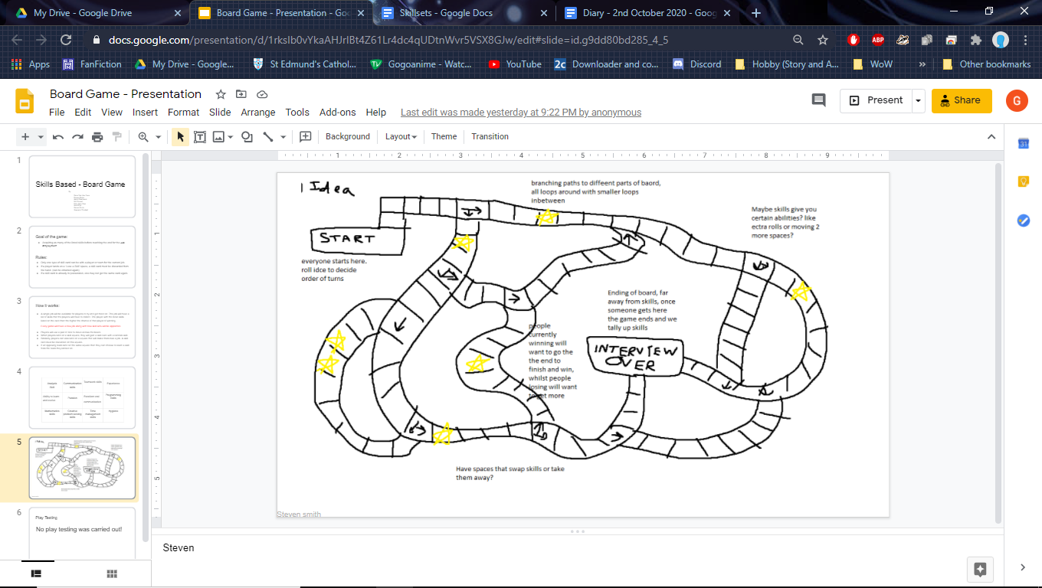

(Figure 1)

**An example of the skills card can be found in Figure 2:**

(Figure 2)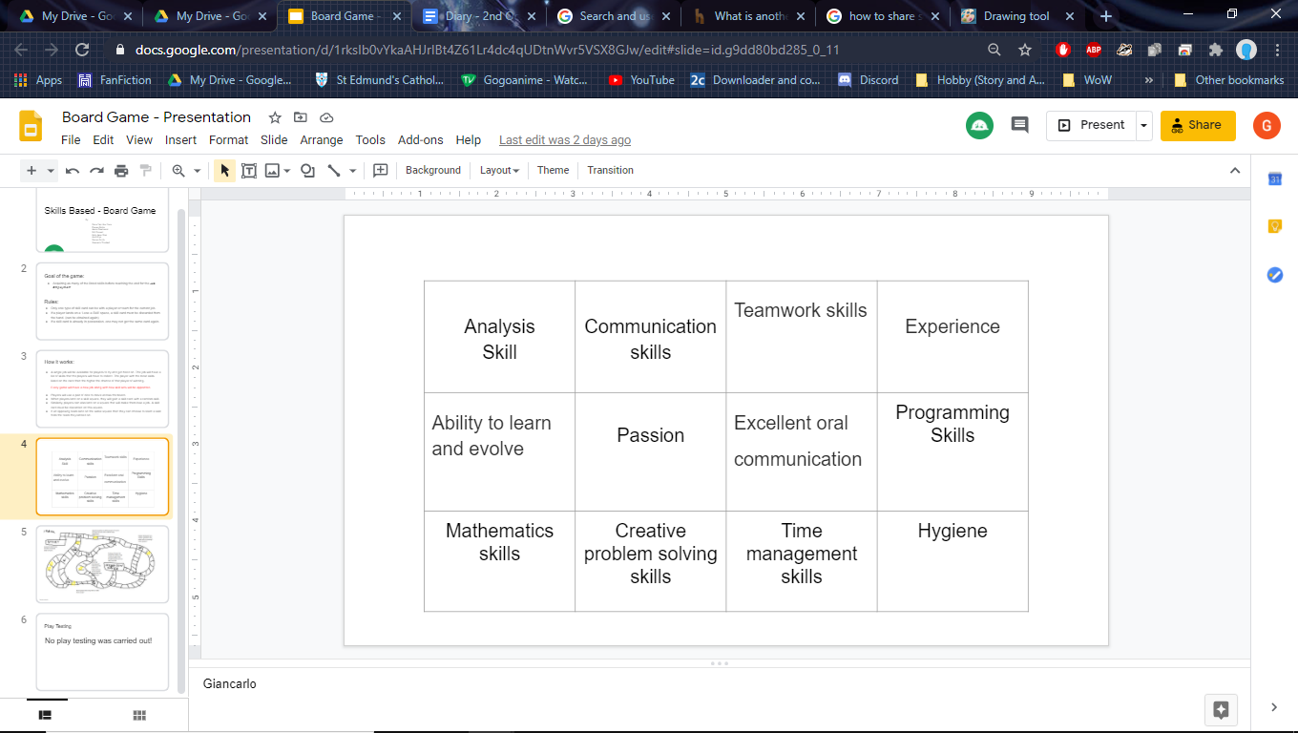

Working in a team was crucial in tackling the creation of the game. Multiple discussions arose during the process on the way the game should have been presented led to poor time management, which then resulted in the loss of any test play opportunities. However at the same time, working with others did allow for unique ideas to arise, that would have not been possible by working alone.

Furthermore this experience was relevant to the fact that one of the key employability skills that employers want from their programmers is the ability to work effectively with a team and have excellent communication skills Teamwork overall is an important aspect of game development as without then the project cannot be completed. Another reason why it is of importance is due to the fact that with teamwork, problems could be tackled in multiple ways which can lead to the most efficient method of solving the problems being found.

Personally, I believe that I managed to effectively communicate my ideas with the team. However my time management would be an aspect of my performance I would want to improve on, because getting lost in the discussion had made me lose track of time. Resulting in the game not being tested on by anyone and hastily made.